1. A screenshot of a social media post

   Description generated with very high confidenceComplete the missing items in the following diagram:
2. What is the purpose of system calls? How to access them?
3. Name three main APIs?
4. Which one is system call and API?

* You need know nothing about how it is implemented.
* You need to obey its formats and understand what OS will do as a result call

1. Explain the API, system call and OS relationship?

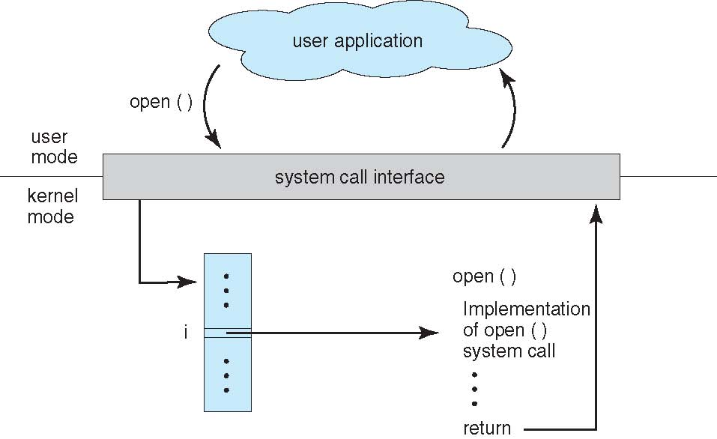

1. Which method of system call passing parameters to the OS is illustrated in the diagram below? What are the other methods?

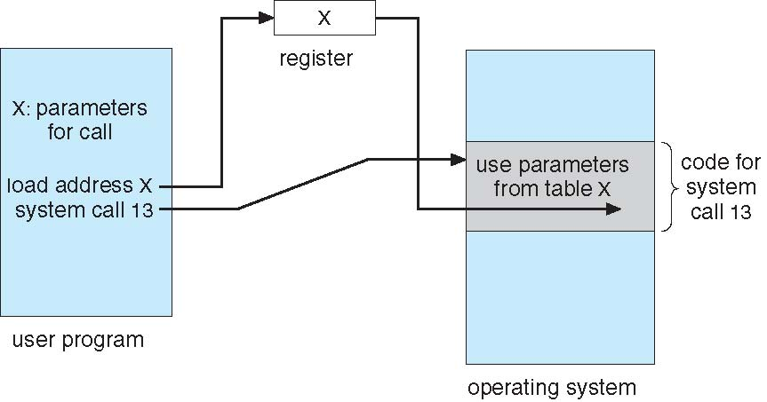

1. Compare the two common models of InterProcess communication?
2. printf() in C program is a system call? Why?
3. What is the difference between policy and mechanism?